# 1. Title Page

Ultrasonic sensor to Arduino

## Publication Number

## System Name

LARAMID

## Model Number

## Date of Issue

March 12, 2019

# 2. Record of Manual Revisions

|  |  |  |  |  |  |  |
| --- | --- | --- | --- | --- | --- | --- |
| **Revision** | **Date** | **Pages Affected** | **Revisions** | **Author** | **Check** | **Approved** |
| 1 | 03/12/19 | All | Document Created | Cathy Lee |  |  |

Table.1 Record of Manual Revisions

# 3. Table of Contents

1. Title Page…………………………………………………………………………………………………………………………………………… 1

a. Publication Number ……………………………………………………………………………………………………………… 1

b. System Name ………..……………………………………………………………………………………………………………… 1

c. Model Number ……………………………………………………………………………………………………………………… 1

d. Date of Issue ………….……………………………………………………………………………………………………………… 1

2. Record of Manual Revisions ………………………………………………………………………………………………………………. 2

3. Table of Contents ………………………………………………………………………………………………………………………………. 3

4. Introduction ………………………………………………………………………………………………………………………………………. 4

5. Principles of Ultrasonic Sensor .…………………………………………………………………………………………………………. 5

6. Connecting Ultrasonic Sensor to Arduino …………………………………………………………………………………………. 6

7. C Code of Ultrasonic Sensor ………………………………………………………………………………………………………………. 7

8. Limitations ………..………………………………………………………………………………………………………………………………. 8

# 4. Introduction

This document explains how to set up ultrasonic sensor with Arduino, and how to implement. Ultrasonic sensors will be mounted on Samwise and used during flight test to detect the distance that Frodo or Mary lift. The ultimate goal is to make sure they lift high enough so that they are not disturbed by Samwise once they take off.

# 5. Principles of ultrasonic sensor

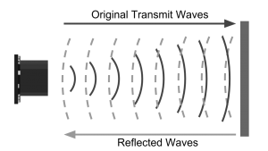

[1] Fig.1 Schematic diagram of how ultrasonic transmits and receives sound waves

<https://www.maxbotix.com/articles/how-ultrasonic-sensors-work.htm>

Transmitter emits ultrasonic sound wave and receiver receives reflected sound wave. Distance is calculated from the time lapses between output and input of the sound wave, using the equation, d=343*t/2. It was divided by 2 because each wave travels twice the distance, emitting and reflecting.

Working angle:

# 6. Connecting ultrasonic sensor to Arduino

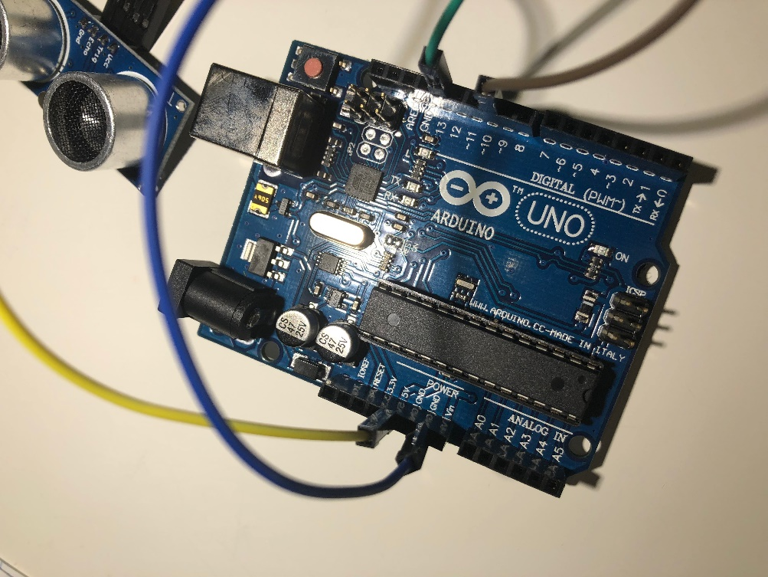

Fig.2 A picture of ArduinoUNO connected with ultrasonic sensor

Vcc: Voltage source 🡪 pin “5V”

Trig: Initiates the pulse 🡪 pin “10”

Echo: Receives the reflected pulse 🡪 pin “12”

Gnd: Ground 🡪 pin “GND”

*Pins for Trig and Echo can be differed.

Then, connect Arduino to computer with a cable

# 7. C Code for ultrasonic sensor

#define trigPin 10

#define echoPin 12

float duration, distance;

// distance in cm

void setup() {

Serial.begin (9600);

pinMode(trigPin, OUTPUT);

pinMode(echoPin, INPUT);

}

void loop() {

digitalWrite(trigPin, LOW);

delayMicroseconds(2);

digitalWrite(trigPin, HIGH);

delayMicroseconds(10);

digitalWrite(trigPin, LOW);

duration = pulseIn(echoPin, HIGH);

distance = (duration/2)*0.0343;

Serial.print("distnace = ");

if (distance >= 400 || distance <= 2) {

Serial.println("Out of range");

}

else {

Serial.print(distance);

Serial.println(" cm");

delay(10);

}

delay(50); // Delay interval between outputs in ms. Can be customized

}

# 8. Limitations

1. Flat

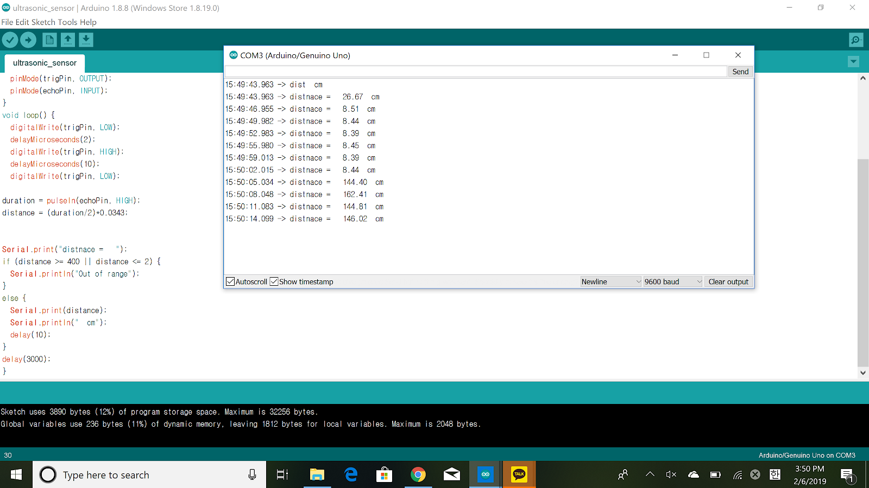 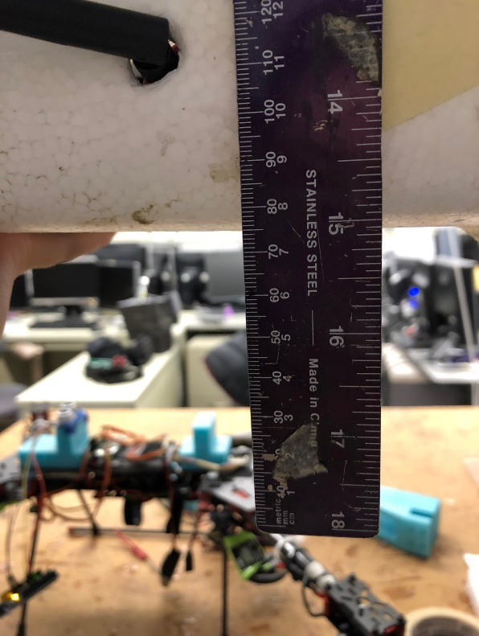

*Expected result, because the bottom is parallel to the sensor.

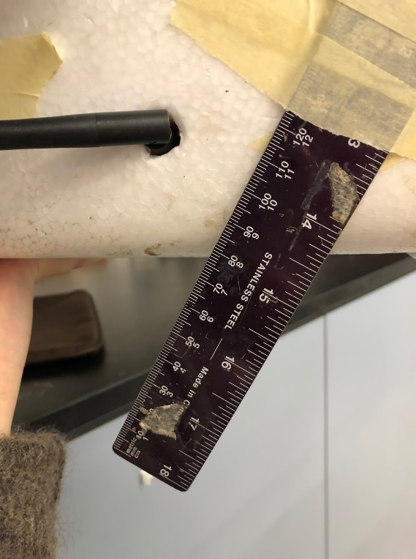

2. Tilted backwards

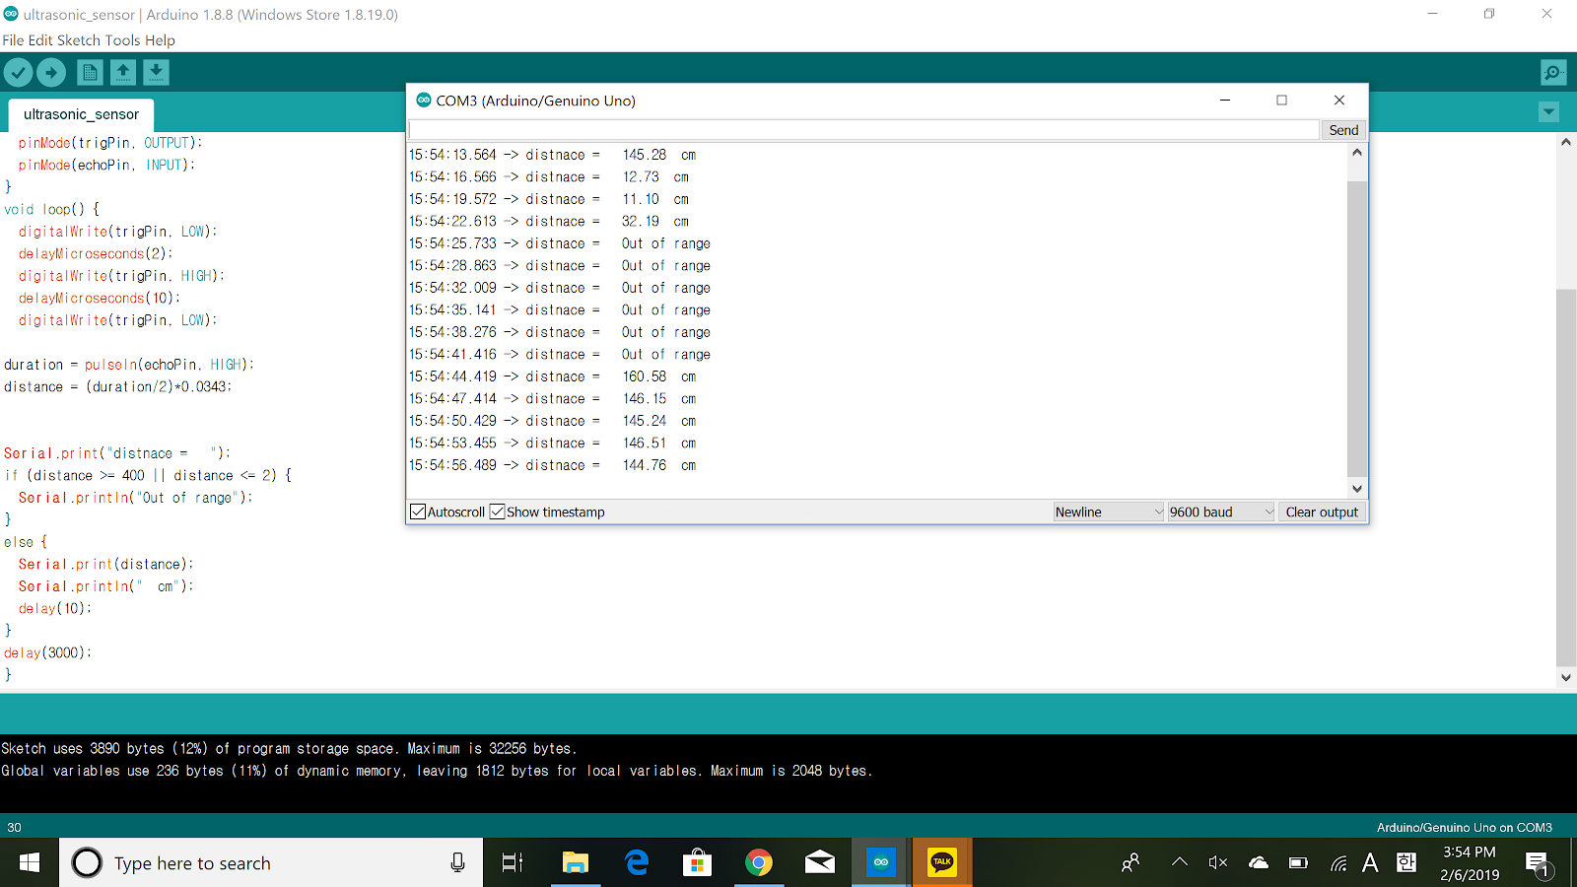

*Out of range, because transmitter and receiver are located side to side. Therefore, the bottom reflects sound wave from transmitter to the front. Receiver has no waves to receive.

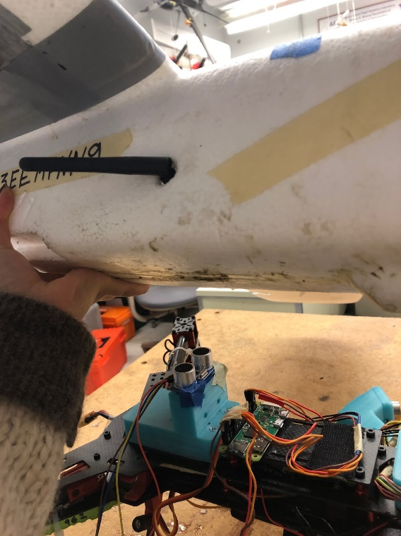3. Tilted to the left

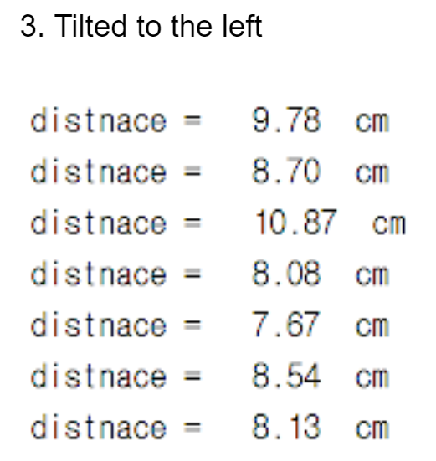

*Distances are within expected results. This is because transmitter is located to the left and receiver to the right. Receiver can receives waves reflected to the right side.

4. Tilted to the right

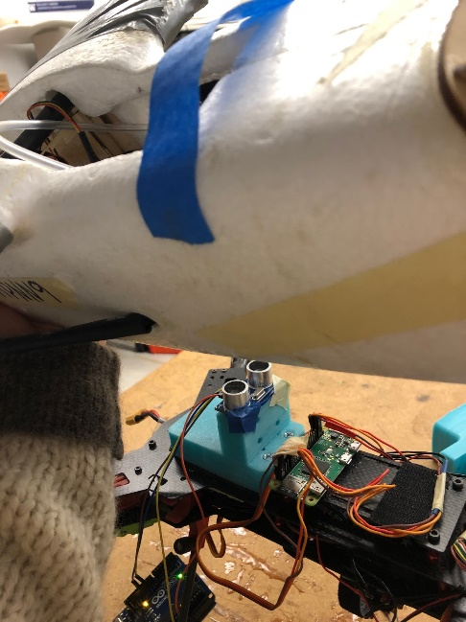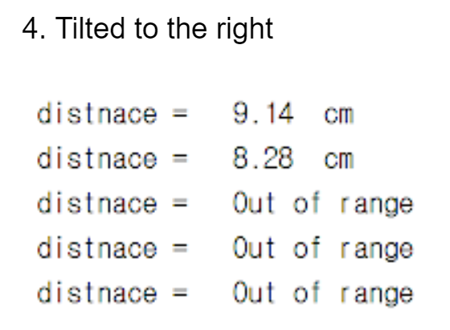

*Out of range. This is because sound waves from transmitter on the left are reflected to the left. Therefore, receiver on the right does not have no waves to receive.

**\*Multiple sensors at various locations and angles are required for flight tests.**